Package 2

1. Review Program Tool and Eservice, update following labels to remove “Fld.”. e.g. Change “Fld. Est. Quantity” to “Est. Quantity” Already fixed 20170105

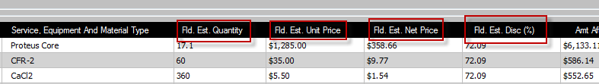

1. Hide “Apply TMA” check boxes. Already fixed 20170105

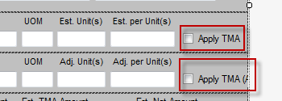

GroupedLineItemControl doesn’t load price item number properly.——UC012.US01

1. Import Product product page from Program Template
   1. Add Product page in Program, similar to it is in Call Sheet. Please see the mocked screen below.—— UC004.US01
   2. Import Product information from “Product Import” worksheet in Program template to Product page in Program——UC004.US02
   3. Transfer Product page data to Call Sheet when creating Call Sheet from Program——UC006.US03

Explaination.

“eService Import Sheet” add following values for product page import. This part make a separate user story that can be implement earlier. ——UC004.US04



For each Job type, there is “Pumping Service Line Type” and “Stage/Plug/Treatement Information” here for import.

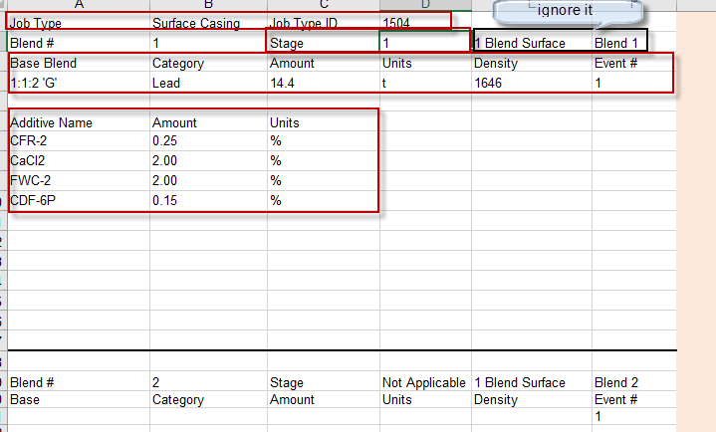

In “Product Import” worksheet, there is “Job Type” and “Job Type Id” to associate the product sections with the Job Type billing information in “eService Import Sheet”

Program Product Page contains following information which can be imported from “Product Import” Page.

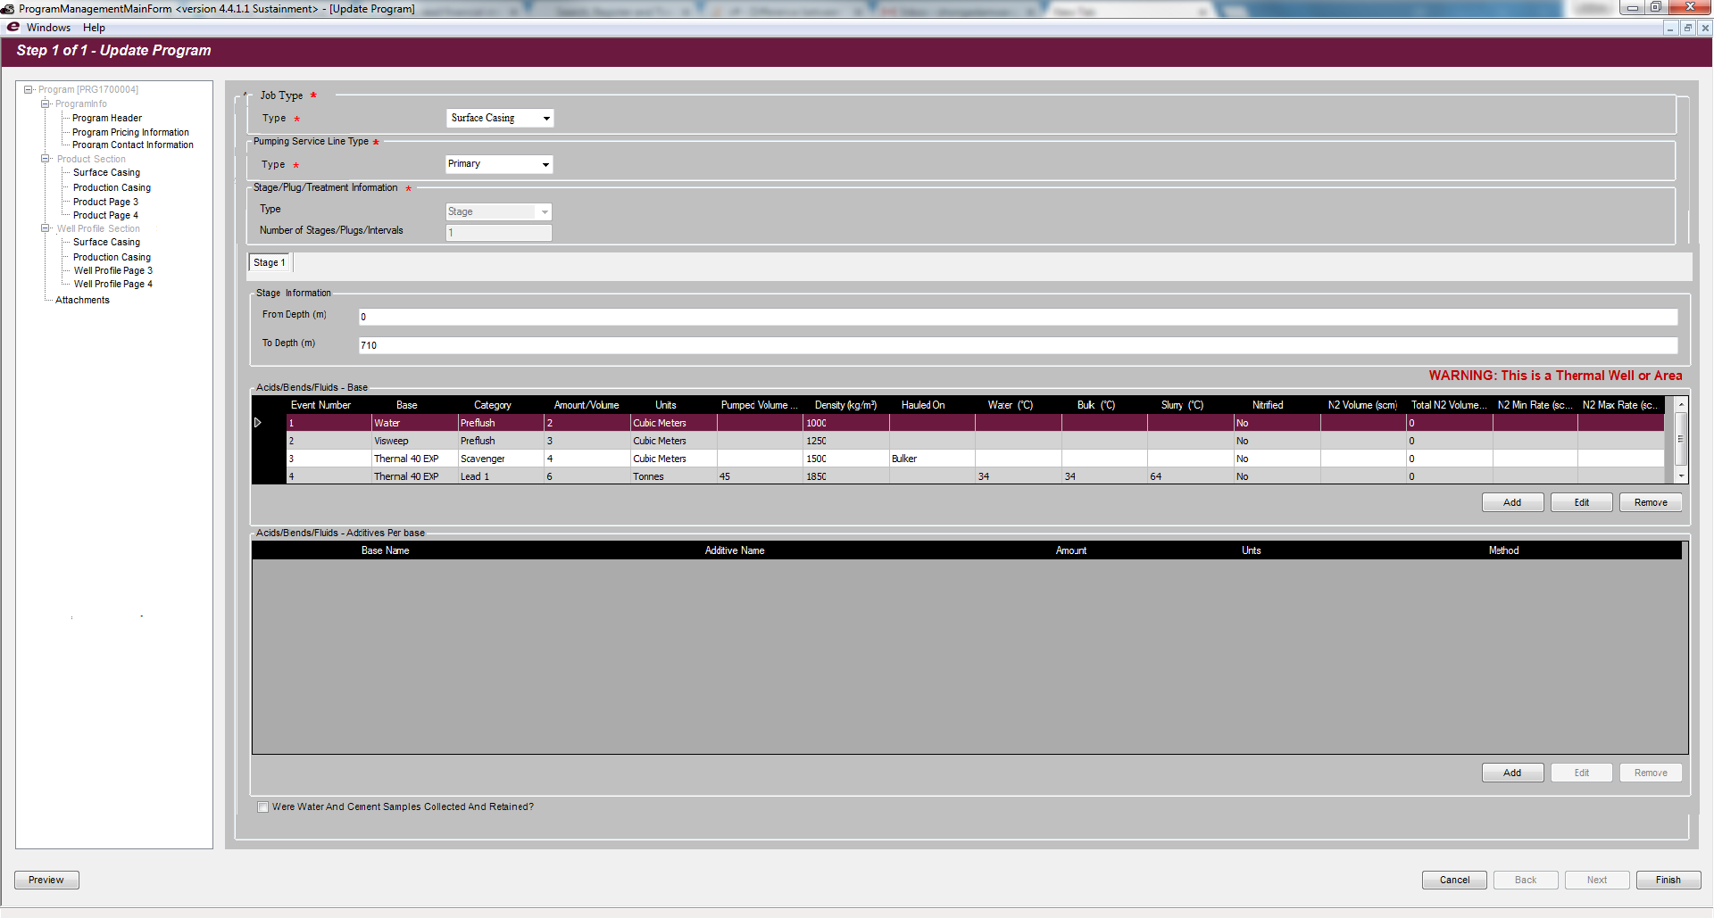

\*\*\*\*\* Please do analysis first and see what data is missing and if we need to adjust the template to make easier to import.

1. Continue refining billing info section calculation
   1. Single item recalculation to backfill the missing estimate values in import template. – This task must be done.—— UC011.US01
   2. Group and Bundle estimate values recalculation.—— UC011.US02
   3. Group and Bundle adjusted values recalculation.—— UC011.US03
2. Micellenous fixes – Up to 40 hours.——UC013.US01
3. eService related printing functionalities - Sanjel
4. Wellbore information import – work load estimate only ——UC005.US01
   1. 新增一个数据项 Targeted Formation, 这个导入会产生除导入之外若干个任务
      1. Program 和CallSheet中增加Formation Section, 具体位置待定 ——UC017.US01
      2. Formation数据表、服务等——UC017.US02
      3. Formation数据传递——UC017.US03
5. eService to Invoice BizTalk ETL – Sanjel
6. Blends/Additives and their mapping with PriceBook , master data clean up – Sanjel
7. Disable Create Program with “NO JDT File” – phase 2——UC015.US01

这个需求，是由于program整体结构变化产生的，涉及到本文档中的12， 13， 14

隐含如下变化：

导入JDT的时候，不再进入导航页面了。原来是进入导航页面，可以修改数据，最后按Finish键保存。现在不用了，直接对导入的数据进行实体验证，如果通过了，保存数据库。如果没通过，返回验证错误信息，此处分两种情况。

* + 1. 如果是致命验证没有通过，如数据库中同一program id如果存在的话，同样programid的program是不可能被重复创建的。——UC015.US02
    2. 如果其他 mandatory fields不能通过验证的话，要提示会被保存为InProgress状态，是否继续。如果是，存入数据库。如果不是，丢弃返回。——UC015.US03

1. Remove well profile page from directly under program. ——UC005.US04
2. Add each job imported well profile page to pumpingjobsection- for display structure see new UI mock. ——UC005.US02
3. Re-organize the program treeview, sub-nodes in “Product Section”, If possible, make the job type name as the node name, and display only the nodes with data. For example, if there only one job type, there should be only one node. If it is too difficult to make it dynamic, just preset 4 sub-nodes and name them as “Product Page 1”, “Product Page 2” and so on. – Phase 2——UC016.US01

Blend and Additive Master Data Look Up instruction

在导入模板中以下两项数据是需要到reference data里查找然后赋值到目标对象中，由于不能提供ID，所以只能用字符串去查找。

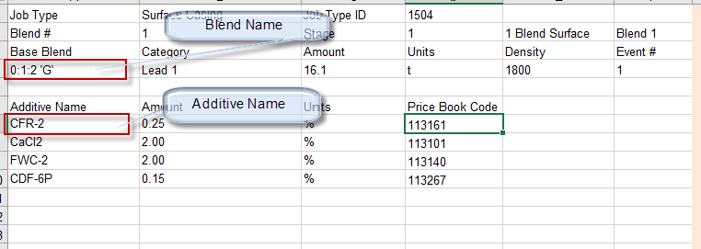

Blend Name对应的数据类型是 BlendFluidType

Additive Name对应数据是 AdditiveType

为保证测试能通过，我准备了脚本把数据更正和加入新数据。在requirements/master data 目录下。

Jan 17 Added

Issues need to be fixed.

1. Group Item – Bundle Type should be Job only, Bundle Category is not needed for now., Grouping Type should be Details Only, Calculation Method should be UnitToTotal only. Quantity is always 1. Corresponding controls should be set as read-only. Unit Price and Net Price are simulated, Amount values are calculated. None of them can be changed. - Done
2. Bundle Item - Bundle Type should be only limited to Job. Since cementing business will only make charge on Job basis. Calculation Method should be limited to “Total to Unit” or “BundleOnly” options. -Done AdjUnitPrice should be readonly. -Done
   1. If Calculation Method is “Total to Unit”, AdjPercentDiscount should be disabled, read-only. - Done
   2. If Calculation Method is “Bundle only”, AdjPercentDiscount set to 0. - Done
3. Adj TMA Amount box on UI should be disabled – Done
4. If Bundle Item and Calculation Method is BUNDLE ONLY, “Add Price Item” button is disabled. -Done.
5. Charge Method not set in program

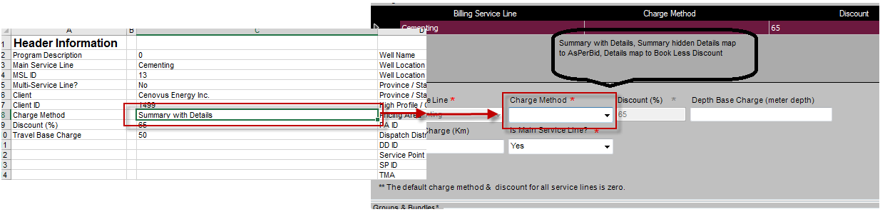

1. Program Generated Date is not correct. When open imported program, program genereated date seems not be set properly, it display 0 as date time. We should set as the datetime when the program in imported.

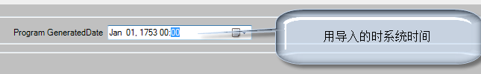

1. After import the program, when first time open the program and make change then save. This happens.

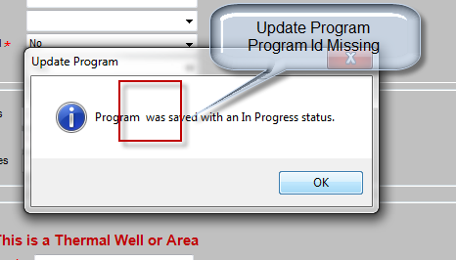

1. After import program, Client name missing in the list. - Done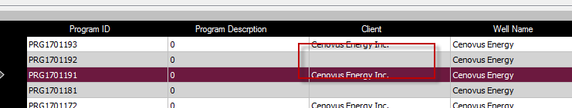
2. Disable Back button in step 2 of 2
3. When program first time imported, Adjust Quantity should be null.

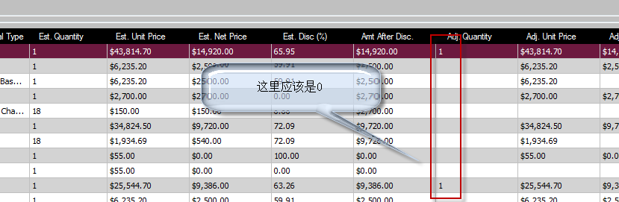

1. Contact information, employ number not shown in bracket

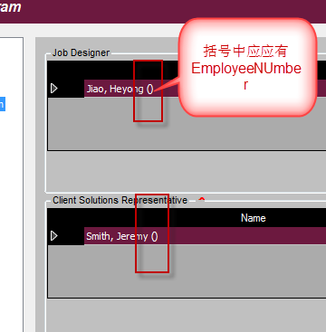

1. In import template, there are values for following fields, Wells, jobs, Stage/Plug/Treatment – Number of Stages, but validation throws non-exist warning

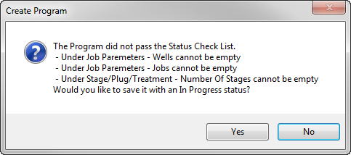

Jan 23, 2017

在导入pricing page中出现如下情况未处理，示例文件为 1,1 2-Stage Cement Job APB.xlsx

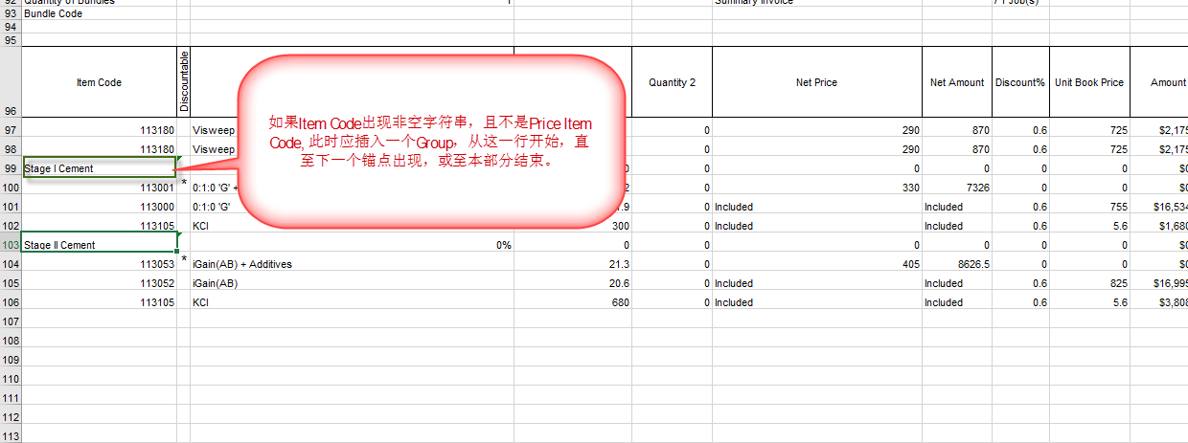

测试说明

新增43个测试用例。导入后，对照Excel导入页的数据与eProgram中导入后的数据。检查

* pricing page导入的结构是否正确，，数据联动是否正确。
* product page导入的分页是否正确，数据联动是否正确。

如果不能导入，或导入出错。确定是导入程序的问题，则修改。不确定的或不能改的，把问题记录下来发给我。